Physical Activity Tracker – Provider App

# Overview

Welcome to the Physical Activity Provider App User Guide. This guide is designed to help you navigate and make the most of the Physical Activity Provider App. The guide is organized into three sections:

* Overview – What this app is for and key stuff to know
* Getting Set Up – How to make your app share and behave the way you want
* Navigating the App – Walkthrough of how to use the application

## Introduction

The app is available for both Android and iOS devices. It can also be accessed directly through your [web browser](https://testphysicalactivity.com/).

This app is intended for use by providers who support patients in improving and sustaining their physical activity levels. The term ‘provider’ is interpreted broadly. It includes licensed clinicians such as general practitioners and specialists (cardiologists, physiotherapists, etc.). However, it also includes licensed professionals such as personal trainers, aerobics instructors, etc.

In some cases, provider EMRs will support all the functionality handled by these apps and there will be no need for the apps at all. However, in some cases providers don’t have EMRs at all, and even when they do, their level of support for physical activity-related interoperability is often limited. This app is intended to help full that gap.

Specifically, this app provides the following capabilities:

* Allows patients to track their physical activity and share information with you and other providers about what they’re doing. This includes information they track and enter themselves as well as information they might gather from their devices. Information that can be shared includes:
  + Type of physical activity performed
  + Total minutes of physical activity
  + Minutes of vigorous physical activity
  + Minutes of moderate physical activity
  + Peak heart rate
  + Total steps
  + Calories
  + Average resting heart rate
  + Patient experience (how much they enjoyed the activity)
  + Additional notes and comments
* Allows you to share relevant health conditions, exercise prescriptions, care plans, and referrals with patients and with other providers
* Allows you to ask a patient to review content (an article, a set of instructions, a video, etc.) on specific web page, to contact a particular provider, or take some other specified action and for the patient to acknowledge their completion of the action (and possibly respond to any questions you might have asked).
* Allows you to initiate referrals to other providers for assessments, education, enrollment in exercise programs, or other types of support for your patients to help them overcome barriers to being sufficiently physically active.

## Patient app

This has a companion app called the Patient Physical Activity Tracker app. You will typically want to give your patients access to this companion app so they can share their physical activity information with you and receive and interact with the information you capture using this app. Use of the patient app is not mandatory – it is possible to use this app only for its referral features or to track care plans and goals without sharing them with the patient. However, including patients in the information sharing process is strongly recommended.

## Legal Stuff

By using the Physical Activity Tracker app, you agree to the following: the App is not a substitute for professional medical advice, diagnosis, or treatment. It is provided "as is" without warranties of any kind, and we are not liable for any data loss or damages arising from its use. You assume all risks associated with using the App. We reserve the right to terminate your access at any time. You will not receive any compensation for using the App or providing feedback. All intellectual property rights belong to the American Heart Association. Continued use of the App indicates your acceptance of these terms. If you do not agree, please discontinue use and remove the App from your device.

## This is a Test

This application is currently in ‘beta’. This means that we’re currently testing it with patients and providers to evaluate how well it meets everyone’s needs. We believe the application is ready for use and we **want** you to use it. However, there may be some features that don’t work well on all devices or things that don’t work the way you might like them to.

First, we ask for your patience and understanding if the application misbehaves or is harder than it should be. Second, we ask for your feedback. Please tell us what doesn’t work or what could work better. What would make this application more useful in helping you to be more active?

Because this application is ‘in testing’, it’s possible there will be some issues or desired features we already know about. We are also creating a list of known issues and limitations. If you want to add your vote asking for a new feature or bugs, feedback can be submitted here.

We will take what we learn from your feedback and work to make the application better.

## Data Server

This app relies on the presence of some sort of storage system that conforms to the necessary interoperability and security standards to allow this app (and patient apps) to create and update records. This server could be offered by one of the other providers in your area (e.g. a local hospital or clinic) or your organization could manage one of your own.

During the test period, the Physical Activity Alliance will run a test server that will host your data and patient data. This data will be kept secure and will not be used for any purpose other than supporting the patient care of you and the other enrolled providers, and running high-level statistics around which features of the app were used by different types of users.

supports you in monitoring patient physical activity, communicating with patients about, including steps, calories burned, heart rate, and activity minutes. It aids in care coordination by allowing you to review, edit, and create conditions, care plans, exercise prescriptions, goals, and referrals for comprehensive patient care. Additionally, it enhances patient interaction by enabling direct engagement, such as creating tasks for patients or requesting them to review information. The app also improves system management by allowing seamless search and management of patient information, thereby enhancing operational efficiency and patient care delivery.

# Getting Set Up

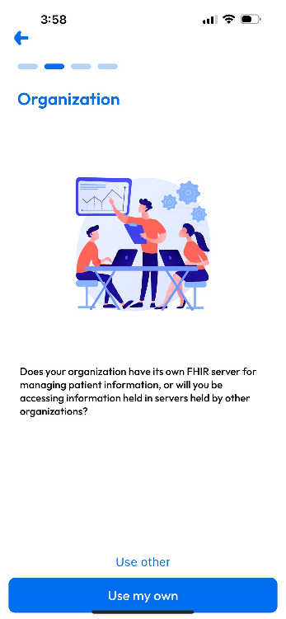The welcome screen is the first screen that appears after launching the application. It displays application information and provides options to set up the app.

## Health Provider Setup

### Health Provider Intro

The Health Provider Intro screen is the first step in setting up your connection with the physical activity server. This pre-screen asks whether your organization has its own server or if you will be accessing information held on servers by other organizations. If you indicate that your organization has its own server, it will prompt you to connect to that server. Otherwise, you will have the option to connect to multiple servers.

For the purposes of the test process, there will only be one server to connect to.

### Connect to Your Physical Activity Server

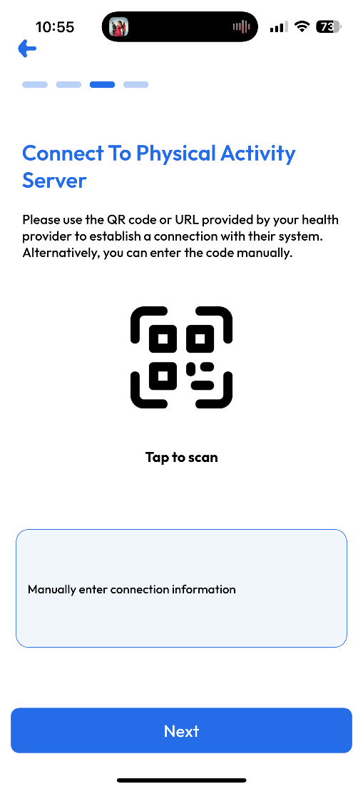This screen sets up the connection between the Physical Activity Provider app and data server. You can connect using:

There are two ways to connect to your server:

* **QR Code Scanning**: In most cases, your local administrator will have given you a piece of paper or a card with a special picture that looks like the one on the right (don’t use the one printed here as it won’t work). If you have one of these, click on "Tap to scan" and point your device's camera at the QR code. This method is quick and ensures that the connection details are accurately entered.
* **Manual Connection**: If you do not have a QR code, there is an option to connect manually. You will need to know the health provider's connection URL and client ID. This information should be provided by your administrator. Click on “Please select connection” and type the information when prompted.

After clicking "Connect," you will be taken to the login screen for the Physical Activity FHIR server to enter your email and password.

During the test process, this will be a *different* password than you typically use for your regular EMR or other electronic system.

### Multiple Connections

If your organization does not have its own server and you need to connect to different organizations, you have the option to add multiple connections. For example, a personal trainer might have connections with servers managed by different local physician clinics. Once an initial connection is established, you can add more servers as needed.

### Selecting Primary Connection

If multiple connections are established, you will need to select a primary connection. This is where data you create will be stored. (I.e. the goals, referrals, exercise prescriptions, conditions, patient tasks, etc.) You will receive information from all servers you connect with and can submit referrals to any of those servers. However, all records you create will only exist on the primary server

# Navigating the App

After the above setup steps, the main screen for the app will appear. This man screen has two modes: **Provider Mode** and **Provider-Patient Mode**.

## Provider Mode

In Provider Mode, users can manage their to-do tasks, including:

* **Sent Referrals and Tasks**: Tasks and referrals you have created for others that require some sort of action. This includes:
  + Draft requests (which you need to complete)
  + Created referrals not yet assigned to a performer
  + Assigned referrals or patient tasks that have been rejected or have failed and may need re-assignment or some other sort of action
  + Completed referrals and patient tasks where the results need to be reviewed
* **Received Referrals**: Tasks requested to be performed by you. Actions include
  + Accepting or rejecting the referral
  + Performing whatever the requested action is.

This mode also includes a **Patient Creation Module**, where the provider can define new patient records. In this patient screen, providers can search for patients by names, edit existing patient records, and create new patients.

If the logged-in provider is an **Admin Provider**, they have additional capabilities:

* **Create and Update Providers:** Admins can create new provider accounts and update existing ones.
* **View All Patients and Providers:** Admins can see the list of all patients and providers within the organization.
* **Create and Update Patients:** Admins can manage patient records and assign patients to any providers within the organization.

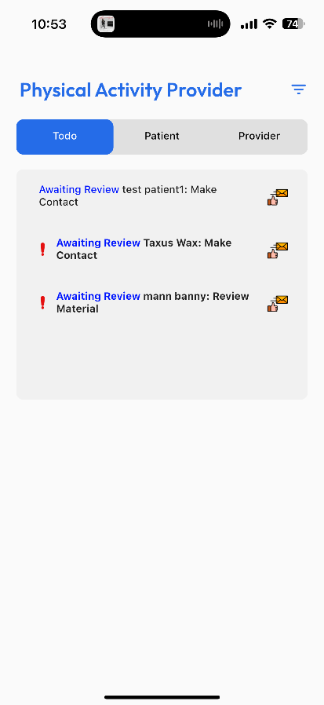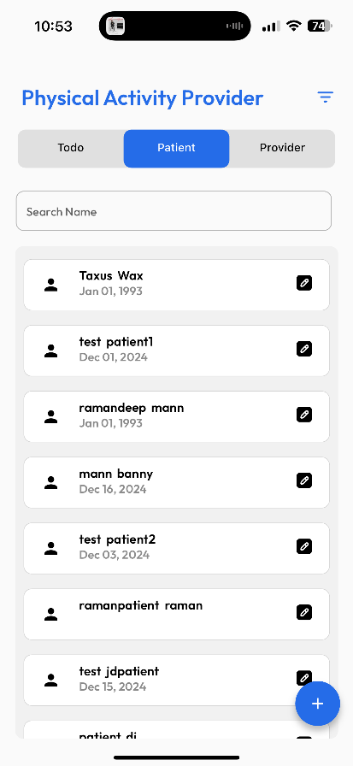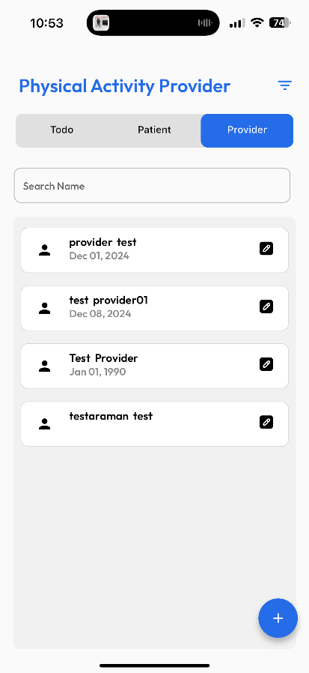

## Provider-Patient Mode

To switch from Provider Mode to Provider-Patient Mode, navigate to the Patient screen and select the desired patient by clicking on their name. This action will seamlessly transition the app into Provider-Patient Mode.

In **Provider-Patient Mode**, the app focuses on managing the selected patient's information and activities. This mode allows the provider to:

* Create and update the patient's health conditions, care plans, exercise prescriptions, goals, and referrals.
* Create various types of tasks for patients, such as reviewing information, making contact, and general information.
* View detailed physical activity data at the weekly, daily, and activity levels for different activity measures.
* Assess the patient's progress using various graphs.

The Main Navigation Bar manages all screens within the provider-patient mode and is divided into: Home Screen, Patient Graphs, Tracking Chart, and Settings. The top right icon displays user details, including provider and patient information.

### Home Screen

The Home Screen serves as the central hub for managing various aspects of patient care in the Physical Activity Provider app. It provides quick access to different sections, allowing you to efficiently manage and update patient information. The sections available on the Home Screen include:

* **Conditions**: This section displays the health conditions of the selected patient. You can create and update conditions to ensure accurate tracking and management. You can also see information contributed by other providers. You and other providers can add notes to condition records.
* **Goals**: This section allows you to set and update goals for the patient. Goals can include various health and fitness objectives that the patient needs to achieve. You can also see goals established by other providers or by the patient themselves. You, other providers, and the patient themselves can add notes to goals
* **Physical Activity Plans**: This section shows the active physical activity plans for the patient. These plans provide details about what the patient should be doing now, as well as the various steps planned over time to help get them to where you and they agree they need to be. Having a shared plan helps to keep the patient and the other providers who are supporting the patient on the same page.
* **Exercise Prescriptions**: This allows you and other providers to formally “order” exercise, just as you might order a medication or other therapy. Research has shown that such orders can be effective in changing patient behavior around physical activity. All such orders entered are available to the patient.
* **Referrals**: This section is used to manage referrals for additional care or services that the patient might need. You can create and update referrals to other providers or provider organizations that offer services that would be helpful to the patient in achieving a higher level of physical activity.
* **Patient Tasks**: This section allows you to create different types of tasks for the patient, such as reviewing information, making contact, or providing arbitrary instructions.

To add new entries in any of these sections, click on the "+" button located at the bottom right of the screen. This button provides quick access to forms for creating new conditions, goals, care plans, exercise prescriptions, referrals, or patient tasks.

**General Points:** "None" indicates that there are no entries for that particular section. "Active: X" indicates that there are X entries with active status in that section, though there may be more entries with other statuses. Additionally, each section has filters to filter the entries by different statuses.

### Patient Graphs

The Patient Graphs Screen offers you a comprehensive view of the patient's physical activity data in a graph format. It allows you to assess the patient's progress over time and compare activity levels across different periods.

Graphs can be plotted for any of the measures, including:

* Activity minutes (Total, Moderate, and Vigorous minutes)
* Heart rate (Rest and Peak)
* Calories burned
* Steps taken
* Experience

These graphs can be plotted at the day-level or week-level, allowing for detailed analysis of the patient's activity patterns. In terms of timeframe, data can be viewed from the last week, 4 weeks, 3 months, 6 months, 1 year, and lifetime.

Other features include:

* **Zoom-In**: Allows you to focus on specific time periods or data points for a closer look.
* **Tooltips**: Provides detailed information when hovering over data points on the graph.
* **Multi-Line Graphs**: Enables plotting of multiple measures on the same graph for comparison.
  + Legends: Explains the lines on the graph, helping to understand what each line represents.

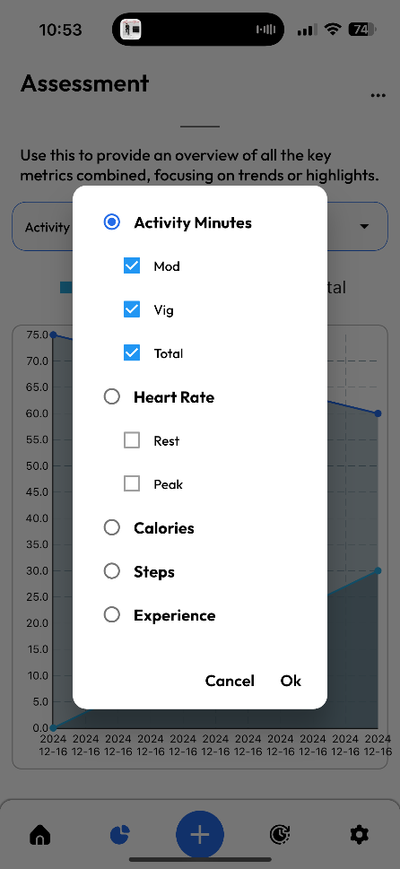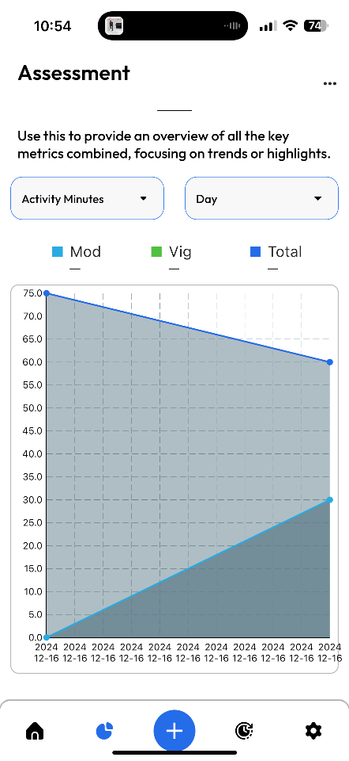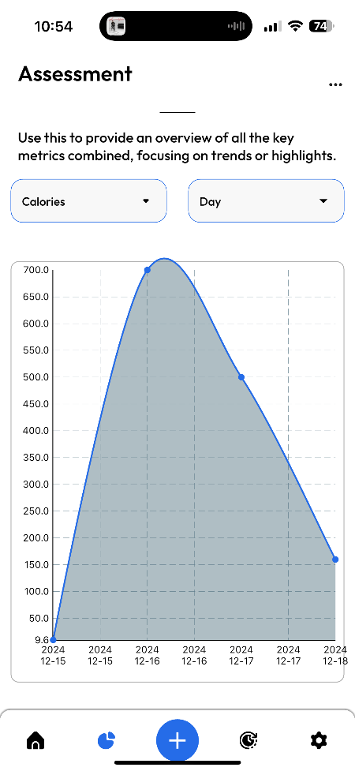

### Tracking Chart

The Tracking Chart visualizes the patient's physical activity data, allowing you to see the patient's progress over different periods (daily, weekly, monthly) and for different activities. The chart is designed to provide an overview of the patient's activity for the last 30 days, displayed in a five-week format. It includes various measures such as total minutes, calories burned, steps taken, and heart rate, depending on what has been configured in the initial setup.

Key features of the Tracking Chart include:

* **Data Levels**: Each measure can be tracked at the activity, daily, and weekly levels. The chart auto-calculates values at higher levels based on the entries at lower levels
* **Navigation and Filters**:
  + **Left Filter**: Allows you to expand/collapse the weeks and days level entries or hide empty rows.
  + **Right Calendar Button**: Allows you to navigate to other weeks/months.
  + **Right Filter Button**: Lets you hide column measures that you do not want to record.
  + **Week Slider**: Located at the top, it lets you scroll to previous and future five weeks.

**Note:** For providers, the Tracking Chart is read-only. This means providers can view the patient's activity data and progress but cannot make any edits or changes.

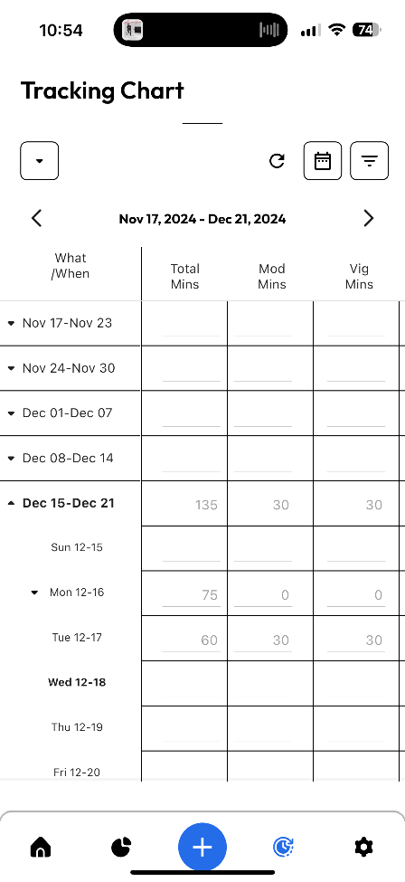

### Settings

The Settings Screen allows you to customize the app's functionality. It includes options for initial configuration, tracking chart settings, synchronization, and diagnostics.

**Setup Wizard**

The Setup Wizard guides you through the initial setup process, ensuring all necessary configurations are made.

**Switch to Provider View**

Switch to Provider View allows you to change the app mode to Provider mode.

**Send Us Feedback**

Send Us Feedback enables users to provide comments and suggestions about the provider and patient app. This opens a feedback form to fill out the details.

